Chapter 3, Solution 79

The schematic is shown below. When the circuit is saved and simulated, we obtain the node voltages as displayed. Thus,

V_{a} = –10.556 volts; V_{b} = 20.56 volts; V_{c} = 1.3889 volts; and V_{d} = –43.75 volts.

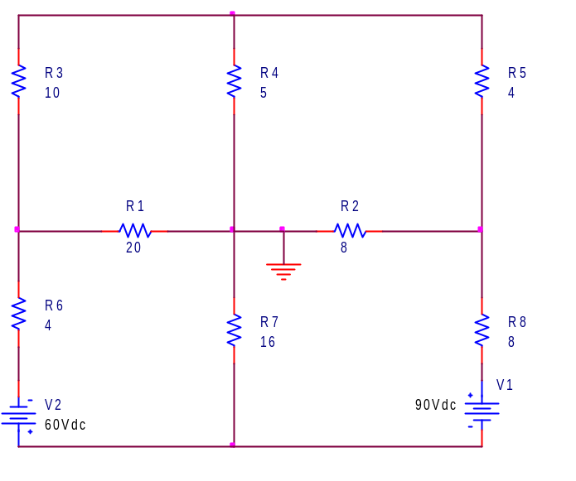
–43.75 V
1.3889 V
20.56 V
–10.556 V

